



**BTEC BUSINESS**

**Pre-transition work 2023-24**

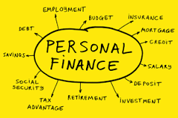



**THE BUSINESS COURSE HAS FOUR UNITS. THEY ARE:**

* **Unit 1 - Exploring Business** – an INTERNALLY ASSESSED COURSEWORK unit where you will compare and contrast two businesses, analyse their organisation and investigate the external factors that affect them. In addition, we will look at how businesses use innovation and enterprise, and justify why it is necessary for many businesses (Year 1, 90 GLH)
* **Unit 3 - Personal and Business Finance –** this unit enables you to learn about personal as well as business finance, introduces you to accounting and requires you to evaluate financial sources for a specific business situation. For this unit, you will sit an EXTERNAL WRITTEN EXAMINATION (Year 1, 120GLH)
* **Unit 2 - Developing a Marketing Campaign** – in this unit you will need to learn about the 7 Ps of marketing, as well as the aims of specific marketing campaigns whilst considering the budget and timescales of campaigns. In an EXTERNALLY ASSESSED ASSIGNMENT you will need to apply this learning to a specific business as well as research the market that the business operates in (Year 2, 90 GLH)
* **Unit 8 - Recruitment and Selection –** an INTERNALLY ASSESSED COURSEWORK UNIT where you will learn about the recruitment and selection process, whilst applying this knowledge and understanding to a specific business of your choice. As part of the assessment you will have to apply for a vacancy, take part in interviews and consider your own personal strengths, weaknesses and areas for development. (Year 2, 60GLH)
* You complete 4 units over two years
* Equivalent in size to 1 A-Level
* Qualification gains UCAS points and is recognised by higher education providers
* Develops employability skills such as cognitive and problem-solving, team working and appropriate research skills

**Grades and Assessment:**

* Able to gain grades from P to D*
* More points are awarded to units with more GLH (Guided Learning Hours). Unit 3 is worth the most points
* The N grade or “Near Pass” means that learners can pass the qualification without passing the external assessment as long as they achieve the N grade and meet all other eligibility requirements, which remain unchanged. Learners will be able to do this if they narrowly miss the Pass grade for **external assessments only**, and if they still achieve enough points throughout the qualification. This gives a UNIT grading system like the one below:

**KEY WORDS IN VOCATIONAL ASSIGNMENTS**

Understanding the command words for different levels is vitally important for success. Below are words that may be used in assignments for the different levels. Fill in the definition of these words on the right-hand side on the table for Pass, Merit and Distinction.

<https://qualifications.pearson.com/content/dam/pdf/BTEC-Nationals/Business/2016/specification-and-sample-assessments/9781446938218_BTECNationals_Bus_ExCert_Spec_Iss3C.pdf>

Copy this link into a URL and find page 126 to find these terms

Download this specification into your documents on your Computer

|  |  |
| --- | --- |
| **Analyse** |  |
| **Assess** |  |
| **Compare** |  |
| **Communicate** |  |
| **Discuss** |  |
| **Demonstrate** |  |
| **Develop** |  |
| **Evaluate** |  |
| **Explore** |  |
| **Examine** |  |
| **Identify** |  |
| **Interpret** |  |
| **Investigate** |  |
| **Justify** |  |
| **Manage** |  |
| **Report** |  |
| **Research** |  |
| **Review** |  |

**ORGANISATION IS THE KEY TO GOOD STUDY SKILLS**

**How to be organised:**

* Number and date all of your notes and handouts to keep them in order.
* Use a folder and file dividers to separate each unit for coursework.
* Take responsibility for catching up if you miss a lesson due to illness. Find the resources that you missed and photocopy a friend’s written notes.
* Check the relevant section in the textbooks and make extra concise notes if it improves your understanding. If you do not feel confident about a particular area, consult your teacher. Never be afraid to ask for help if you do not understand.
* Always come prepared to class, bringing course handbook, writing equipment, class notes from previous lessons, diaries etc.
* If at any point you feel overwhelmed by the work – call for help – wave – do not drown!

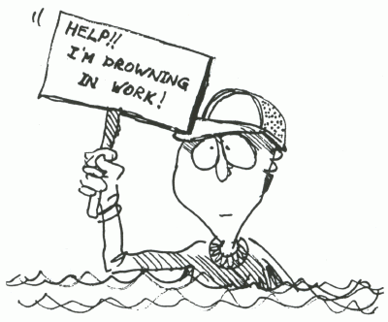

**RECOMMENDED RESOURCES:**

<https://www.bbc.co.uk/bitesize/subjects/zpsvr82> - the business area of BBC bitesize. Whilst aimed at GCSE, this will also provide useful information on many areas, especially if you did not do GCSE

[www.tutor2u.net](http://www.tutor2u.net) – website which includes a Business area. Full of blog posts, resources and definitions

[www.beebusinessbee.co.uk/](http://www.beebusinessbee.co.uk/) - a website specifically for BTEC Business courses

<https://www.bbc.co.uk/news/business> - the business area of the BBC news site for unbiased up to date news on the economy, businesses and money

<https://www.economicshelp.org/> - a website to help with the economic aspects of the business course

<https://businesscasestudies.co.uk/> - a website with detailed information about some businesses related to specific areas of business theory

Pearson Revision Guide – invaluable for the externally assessed units

You Tube has some great videos. I would recommend looking for the following first:

* Tutor2u
* Two teachers
* BeeBusinessBee!!
* Bizconsesh
* Time2resources

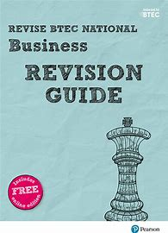

**TASK 1: OWNERSHIP AND LIABILITY**

Businesses are owned in one of three ways; private, public and not-for-profit.

Find a definition of private, public and not-for-profit and provide EXAMPLES of businesses that come under that sector

<https://www.tutor2u.net/business/topics/public-sector>

<https://www.tutor2u.net/business/topics/private-sector>

Businesses tend to be owned under the following categories; sole trader, partnership, private limited company, public limited company, franchise and not-for-profit / social enterprises.

Fill in the table below – an example has been completed for you

|  |  |  |  |  |
| --- | --- | --- | --- | --- |
| Type of Business | Definition | Example | Advantages | Disadvantage |
| Sole Trader | A business owned by just one person | Decorator, Pilates Instructor | Gets to keep all the profit and can make all the decisions | Unlimited Liability – Liable for all the debts |
| Partnership |  |  |  |  |
| Private Limited Company |  |  |  |  |
| Public Limited Company |  |  |  |  |
| Franchise |  |  |  |  |
| Not-for-Profit / Social Enterprise |  |  |  |  |

<https://www.tutor2u.net/business/reference/business-organisation-introduction-to-business-ownership>

<https://www.tutor2u.net/business/topics/sole-trader>

<https://www.tutor2u.net/business/topics/private-limited-company>

To protect a business against the risk of being sued or help legally responsible, anyone owning or running a business should insure against such liability. Liability can be; limited or unlimited.

Provide a definition of both limited and unlimited liability

<https://www.tutor2u.net/business/topics/limited-liability>

**TASK 2: BUSINESS SECTORS**

**Sectors**

Business operate in different sectors according to the nature of their business and the product or service they provide. These are known as; primary, secondary, tertiary and quaternary

Provide definitions and examples of businesses that come under each sector:

Primary -

Secondary -

Tertiary -

Quaternary -

<https://www.tutor2u.net/business/reference/operations-the-production-process>

**TASK 3: STAKEHOLDERS**

**Stakeholders**

Every Business has stakeholders, and these are people who are influenced by business activity. They can be internal (within the business) or external (outside the business).

Fill in the table below, thinking about what each stakeholder would want from a business. The first stakeholder has been completed as an example:

Internal Stakeholders:

|  |  |  |
| --- | --- | --- |
| Internal Stakeholder | What is their stake in the business | How much influence do they have? |
| Shareholders / Owners | They will want profits / dividends from the business and are ultimately concerned with how well the business is doing | They are very powerful as they could withdraw their money from companies and could influence decision making |
| Employees |  |  |
| Managers |  |  |

<https://www.tutor2u.net/business/topics/stakeholder>

External Stakeholders:

|  |  |  |
| --- | --- | --- |
| Internal Stakeholder | What is their stake in the business | How much influence do they have? |
| Suppliers |  |  |
| Lenders |  |  |
| Competitors |  |  |
| Customers |  |  |
| Government |  |  |
| Local Community |  |  |
| Pressure Groups |  |  |

<https://www.tutor2u.net/business/topics/stakeholder>

**TASK 4: KEY TERMS, UNIT 3:**

**­­**There will be some key terms that will be important to know for Unit 3, Personal and Business Finance. Please find definitions for the following key terms:

|  |  |
| --- | --- |
| **Easy Key Term** | **Definition** |
| Debit Card |  |
| Credit Card |  |
| Electronic Transfer |  |
| Direct Debit |  |
| Standing Order |  |
| Pre-Paid Cards |  |
| Contactless Cards |  |
| Charge Cards |  |
| Store Cards |  |
| Mobile Banking |  |
| BACS |  |
| CHAPS |  |
| Bank of England |  |
| Banks |  |
| Building Societies |  |
| Credit Unions |  |
| National Savings and Investments |  |
| Pension Companies |  |
| Pawnbrokers |  |
| Payday Loan Companies |  |
| Financial Conduct Authority |  |
| Financial Ombudsman Service |  |
| Financial Services Compensation Scheme |  |
| The Consumer Credit Act |  |
| Citizens Advice |  |
| Independent Financial Advisor |  |
| Money Advice Service |  |
| Individual Voluntary Arrangements |  |
| Bankruptcy |  |

**TASK 5: LITERACY, UNIT 3:**

# Why are UK banks taking so long to pass higher interest rates on to savers?

**A**ctivists, campaigners and MPs are growing increasingly concerned that savings rates are failing to keep pace with the rapid rise in borrowing costs, putting the behaviour of the UK’s biggest banks in the spotlight. While worries are mounting about how mortgage holders will cope with higher interest rates, less focus has been put on savers. This group is often frustrated when mortgage rates seem to rise lock-step with the Bank of England’s base rate, while savings rates seem to be lower and slower to respond.

Banks’ profits are generally improved by an increase in interest rates. It tends to boost net interest income: the amount of money banks claw in from higher borrowing costs now outpaces the amount they pay out in interest on deposits.

A clear picture of how big the profit haul from higher rates may prove to be has not emerged yet, given how rapidly rates have risen this year versus last.

Commentators such as [Martin Lewis](https://www.theguardian.com/money/2023/jun/20/mortgage-ticking-timebomb-i-warned-of-has-exploded-says-martin-lewis), the MoneySavingExpert.com founder, have argued there is a moral case for banks to offer better savings rates to consumers after taxpayers bailed out financial institutions after the 2008 financial crisis. The consumer group Which? has called some of the savings rates on offer “measly”. The Bank of England’s key interest rate has been above 4% since February this year, climbing to 5% on Thursday.

Easy access savings accounts at large high street banks have been slow to rise. Barclays offers just 0.85% on its easy access Everyday Saver; HSBC 1.35% on its easy access Flexible Saver; and NatWest 1.11% on its Flexible Saver account for savings under £25,000. If a consumer locks their money away for 12 months, they can get rates as high as 7% at some big banks. Some smaller competitors, such as GB Bank, Oxbury bank, and the building societies Principality and Coventry offer easy access accounts with more than 4% interest, according to MoneyFacts data.

This discrepancy is under intense scrutiny from the City watchdog. The Financial Conduct Authority has already warned banks it may introduce a minimum rate for such products if consumers continue to face “loyalty penalties” by looking to their current account provider, often a high street bank, for saving products.

Lewis [tweeted](https://twitter.com/MartinSLewis/status/1671873161938501634?s=20) on Thursday: “The fact banks are only fully passing rate rises on to borrowers not savers is counterproductive and profiteering. Encouraging saving, takes money out of the economy to help inflation too. Govt should be pushing hard to ensure banks don’t just increase margins.” But when putting pressure on banks, industry and regulatory insiders believe it is important to do so in a nuanced way: pushing for better rates on some easy access savings accounts for a wider pool of savers if it suits their needs, rather than expecting an immediate equalisation of mortgage and savings rates, which can respond to different factors. Relatively wealthy, savvy savers who can lock away their money for a long time are able to get very attractive rates already.

Eric Leenders, the managing director of personal finance at the banking lobby group UK Finance, said: “It’s very easy to save when you’re in well-paid salaried employment; it’s very difficult when you’ve just about budgeted and all your surplus cash is gone.”He added that the industry could do more to help consumers work out their medium- and long-term financial goals – which was also part of the a new, regulator-imposed [“consumer duty”](https://www.theguardian.com/business/2022/jul/27/bosses-at-city-firms-could-face-fines-for-failing-to-prioritise-consumers).

The FCA is to impose the consumer duty from 31 July. The rules, which the watchdog has statutory powers to enforce, will require banks to show their customers get a “fair price” and “suitable products and services”, and that “diverse consumer needs are met”.

In February, the FCA wrote to banks and building societies warning them of a need to show evidence to their boards and the watchdog that savers were getting fair outcomes.

Some senior bankers who support the principle of the new duty are concerned about how effectively it will be enforced by a resource-strapped regulator. While the FCA has promised [“onerous interventions”](https://www.theguardian.com/money/2023/apr/20/regulator-warns-uk-banks-miserly-savings-rates-interest-loyal-customers) if consumers are poorly served by sticking with a bank for its savings products, it remains unclear what that will mean in practice. Lewis and charities are among those watching and waiting to see whether the consumer duty has a real impact. Citizens Advice [said the duty](https://www.citizensadvice.org.uk/about-us/our-work/policy/policy-research-topics/consumer-policy-research/consumer-surveys-consultation-responses/a-new-consumer-duty-response-to-the-fca-from-citizens-advice/) needed “to be underpinned by clear, unambiguous rules, effective monitoring and proactive enforcement”.

Still, even a well-enforced duty would face limits on how it can influence savings rates.

The rates on these products – as well as on mortgages – are not only influenced by profit greed, or the Bank of England’s key interest rate. The balance sheets of banks treat deposits (savings) as liabilities and lending (unsecured loans, mortgages) as assets. They carry different risks and so they are priced differently, banks claim.

A good test for working out if banks are poised for big profits are investors’ views on whether rising interest rates are expected to translate into a windfall. They watch a bank’s lending rates versus its rates for deposits – they call this the “jaws” or net interest margin. So far, it is not looking like a bonanza, at least for UK high street retail banks. Shares in three out of the big four – Barclays, Lloyds and NatWest – have fallen the year to date. HSBC is an outlier with its shares up significantly so far in 2023 after announcing it will quit a range of smaller markets, although the UK also accounts for a relatively small part of its global business empire.

Some banks sustained profits throughout a decade of low interest rates, but investors believe this was because they generally track economic growth. The near-term forecast for UK gross domestic product is meagre at best.

A spokesperson for HSBC UK said the bank provided a broad range of savings products to consumers, adding: “We have increased interest rates on savings accounts a dozen times in just over a year, and every savings product has seen its interest rate increase on multiple occasions during that time, supporting customers to start a positive savings habit and save towards longer term goals. We will continue to keep rates under review.”

**Write a summary of the article below:**

**

**GENERAL OPTIONS MAP FOR POST 16 EDUCATION:**

**WHEN CHOOSING PATHWAYS, THERE ARE A NUMBER OF OPTIONS:**

**

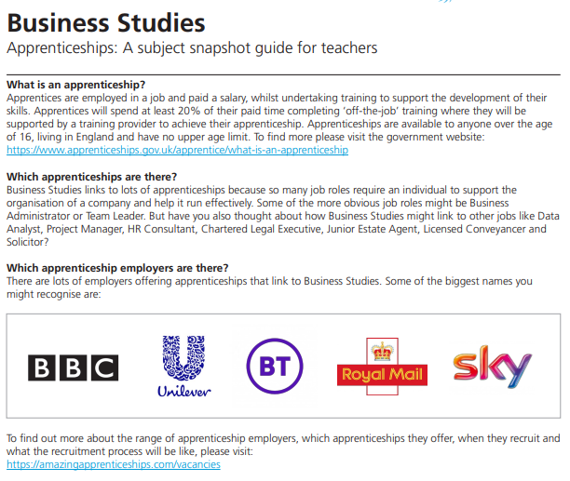APPRENTICESHIP OPPORTUNITIES

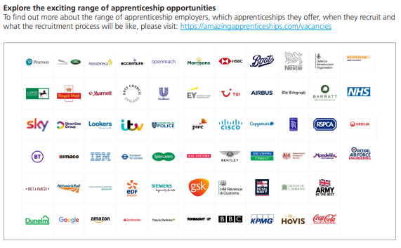

[Amazing Apprenticeships](https://amazingapprenticeships.com/)

[Find an apprenticeship - GOV.UK (www.gov.uk)](https://www.gov.uk/apply-apprenticeship)

[Employability Skills, What Do You Mean? | MYPATH Careers Resources (mypathcareersuk.com)](https://www.mypathcareersuk.com/employability-skills-what-do-you-mean)